2/25/2015

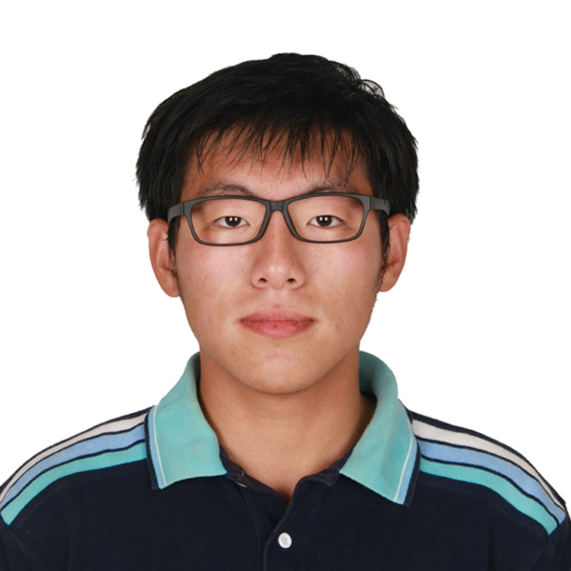

HW3 ELEC345

# Understanding RANSAC

## Ransac Line Fitting

Fit result:

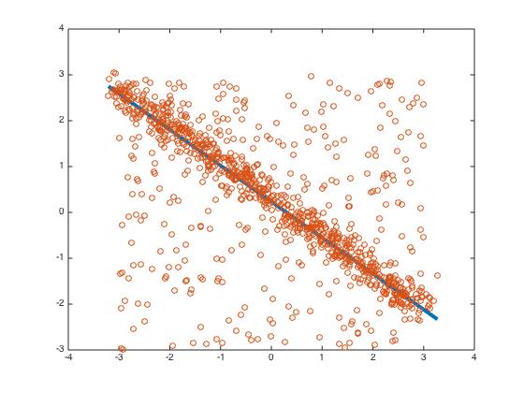

## What value will you choose for the initial number of points s and why?

## s=2 because this is the minimum point needed to fit a line.

## What would be an appropriate choice for the threshold t?

## This depends on the data, for this set, for this set, t = 0.8 seems good. (City block distance)

## What should be the value of the number of samples N so that with probability p = 0.9999, at least one sample is free from outliers?

## In worst case scenario, e = 0.5, and for p = 0.9999, N=32.



## Ransac for Affine Fitting

## ../HW3/CompareCastle.jpg

Left is the original transformed picture, right is the transformed picture using the affine parameters find using Ransac.

Using 6*6 matrix makes this Task much easier.

a1=0.787992465183948a a2=0.120782158858002

a3=10.0323510911381 a4=-0.138984980482043

a5=0.689499753332697 a6=169.982682813819

I used Ransac and find out the maximum inliner ratio, and then find all the maximum parameters and average them to get the final result.

## What value will you choose for the initial number of points s and why?

## s=3 because this is the minimum point needed to get all 6 parameters.

## What would be an appropriate choice for the threshold t?

## This depends on the data, for this set, for this set, t = 4 seems good. (City block distance)

## What should be the value of the number of samples N so that with probability p = 0.9999, at least one sample is free from outliers?

## In worst case scenario, s=3, e = 0.5, and for p = 0.9999, N=69.

# Distance Transforms and Chamfer Matching

## Distance Transform

1. Compute the Canny edge map image of the cow and display the result.

I used Matlab edge function to get the edge map.

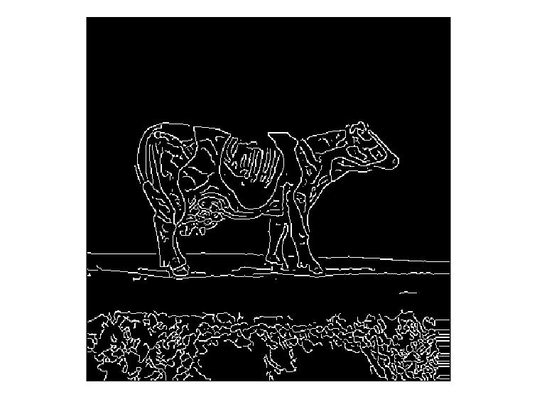

2. Compute the L1 distance transform image of the cow with your own code and display the result.

I run the loop forward and backward to get the distance transform.

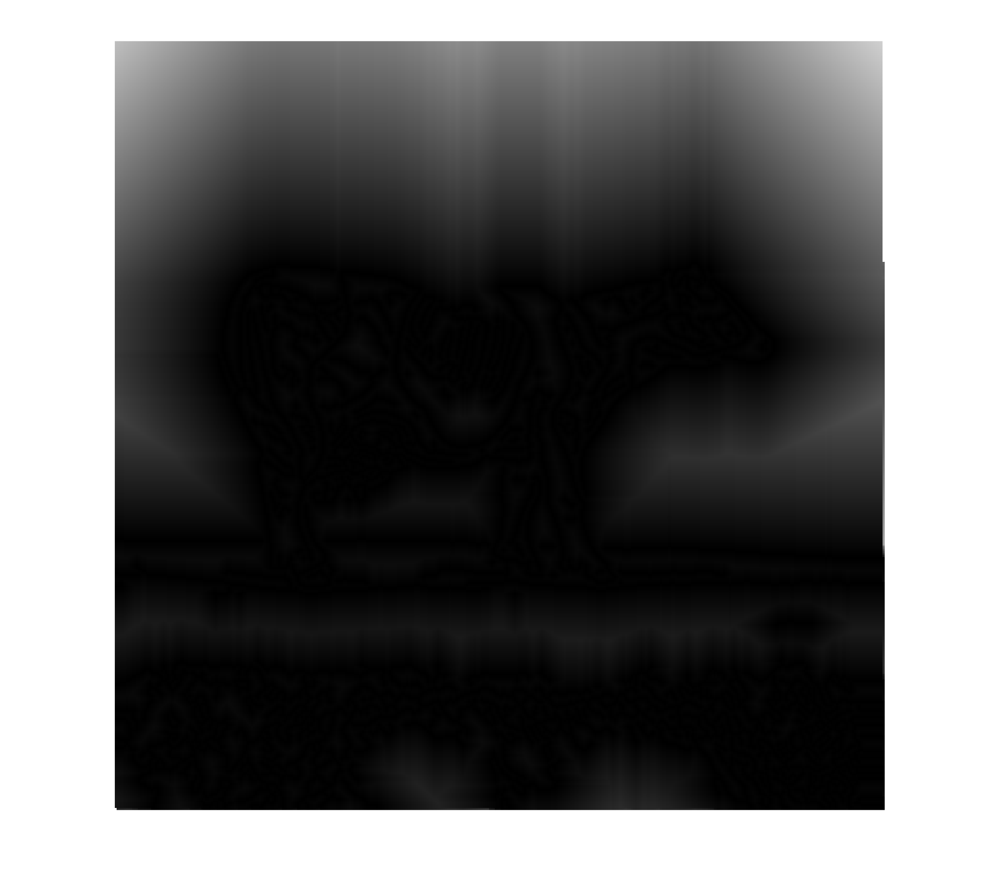

3. Compute the distance transform of the cow edge map with three different metrics using bwdist. Comment on the differences between these. Under what circumstances would the various distance metrics be useful?



Left to right: City block, Chessboard, Euclidean.

For City block, the shadows extend along x and y.

For Chessboard, the shadows extend along x+y and x-y

For Euclidean, the distance transform has no direction preference and it is the most physical one.

The first two calculations are faster. If you need a more accurate distance transform. Euclidean will be the best choice.

## Chamfer Matching

1. What is the minimum Chamfer distance for the given template?

1438. Adding all pixel distance together.

2. Is there a better way to search for the minimum chamfer distance rather than doing an exhaustive search? Suggest an alternative.

Try a set of selected point (1 per 10 pixels for both X and Y), then find out the larger value region and then do a search there.

3. Display the final image of the cow with the template correctly superimposed on it.



I changed pixel values to [255,255,255] for the template location.

# PS: For Matlab code, use HW3_Haoran.m will give you all result.